Jenkins Errors

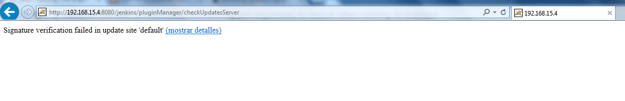

For this issue we have to edit /etc/default/jenkins and add the following to JAVA_ARGS:

-Dhudson.model.DownloadService.noSignatureCheck=true

Environment:

Ubuntu 14.04

OpenJDK Runtime Environment (build 1.8.0_91-8u91-b14-0ubuntu4~14.04-b14)

Jenkins 2.1

Linux was1 2.6.18-238.el5 #1 SMP Thu Jan 13 16:24:47 EST 2011 i686 athlon i386 GNU/Linux

java version "1.8.0_91"

Java(TM) SE Runtime Environment (build 1.8.0_91-b14)

Java HotSpot(TM) Client VM (build 25.91-b14, mixed mode)

**Linux / UNIX:**

In *nix, changes to the catalina.sh file should be picked up

#!/bin/sh

JAVA_HOME="/usr/local/java/jdk1.8.0_91/jre"

JAVA_OPTS=-Dhudson.model.DownloadService.noSignatureCheck=true

export JAVA_HOME

export JAVA_OPTS

**Linux / UNIX as JVM:**

/usr/local/java/jdk1.8.0_91/bin/java -Dcom.sun.akuma.Daemon=daemonized -Dhudson.model.DownloadService.noSignatureCheck=true -Djava.awt.headless=true -DJENKINS_HOME=/opt/jenkins -jar /opt/jenkins/jenkins.war --logfile=/opt/jenkins/jenkins.log --webroot=/opt/jenkins/cache/jenkins/war --daemon --httpPort=8383 --httpListenAddress=192.168.15.4 --debug=5 --handlerCountMax=100 --handlerCountMaxIdle=20

**RedHat Linux based distributions**

If your configuration file is under /etc/sysconfig/ look for the argument JENKINS_JAVA_OPTIONS. It should look something like this:

JENKINS_JAVA_OPTIONS="-Djava.awt.headless=true"

And must be like this:

JENKINS_JAVA_OPTIONS= -Dhudson.model.DownloadService.noSignatureCheck=true

-Djava.awt.headless=true

**Debian / Ubuntu based Linux distributions**

If your configuration file is under /etc/default/ look for the argument JAVA_ARGS. It should look something like this:

JAVA_ARGS="-Djava.awt.headless=true"